Difference between Packed and Unpacked Arrays in SystemVerilog
Packed and unpacked arrays in SystemVerilog differ in terms of organization, storage, indexing, and use cases. Here's a detailed comparison:
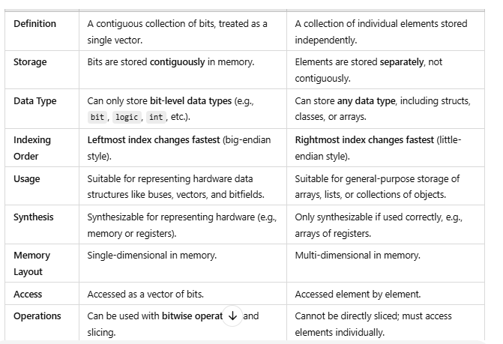

Comparison Example
Packed Array:
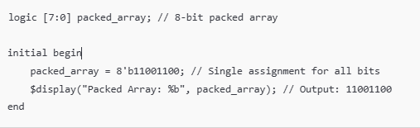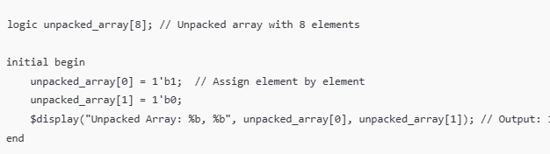
Unpacked Array
Feature | Packed Array | Unpacked Array
Declared | Left of name | Right of name
Bit storage | Contiguous | Separate elements
Acts like vector | Yes | No
Can slice ([7:4]) | Yes | No
Used in DUT | Yes | Limited
Used in Testbench | Limited | Yes
Supports dynamic size | No | Yes
Synthesizable | Yes | Yes (fixed size)

